The first data set and corresponding visual model I would like to discuss is data gathered and presented by the Central Statistics Office (CSO) in Ireland (i). The data provided is of the size of the population citizens in Ireland within specified age ranges (i.e. 0-14 years old, 15-24, etc..). The data is visualised using a simple horizontal bar chart.

**Age Group** **2016**  **2017**

Both sexes

0 - 14 years 1,005.5 1,007.0

15 - 24 years 574.7 584.8

25 - 44 years 1,401.5 1,398.1

45 - 64 years 1,128.0 1,152.7

65 years and over 629.8 649.9

All ages 4,739.6 4,792.5

Male

0 - 14 years 514.2 514.6

15 - 24 years 292.8 297.9

25 - 44 years 685.4 683.4

45 - 64 years 561.0 572.7

65 years and over 293.2 303.4

All ages 2,346.5 2,372.1

Female

0 - 14 years 491.3 492.4

15 - 24 years 281.9 286.8

25 - 44 years 716.1 714.7

45 - 64 years 567.0 580.0

65 years and over 336.6 346.4

All ages 2,393.1 2,420.4

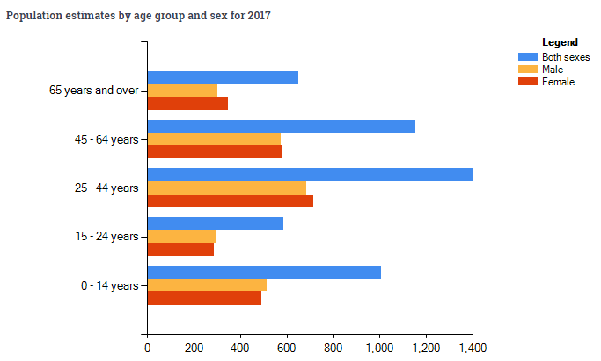

The data is represented in thousands, meaning everyone is not being represented, instead the groups are rounded to the nearest 100, or 1 decimal place. The groups are not clustered based equal differences between the oldest and the youngest individual, but rather on what appears to be a social interpretation of which ages are most likely to be associated. The first cluster being 0-14-year olds (14 years), this incorporates preschool, primary school and more junior cert students in the Irish school system. The next cluster, 15-24-year olds (9 years) incorporates leaving cert students, secondary school graduates and college students. These clusters seem to indicate groups that society would consider as young children, and young adults. The third cluster which incorporates 25-44 years olds (19 years) is probably reflective of young to middle aged professionals, the people most likely to be building homes and families. The fourth cluster containing 45-64-year olds (19 years) are older professionals who have finished having children and are preparing for retirement. While the final cluster is the largest being all of those above 65 years old, that being the legal age of retirement in Ireland.

This simplified version of the population of Ireland by age is an indicator of the value and the intended use of the data. By understanding the sizes of the populations within these groups at this stage we can fairly accurately predict the sizes of those groups in 10/20/50 years’ time. This is useful in understanding the kind of services and infrastructure that the country will require to meet the demands of these groups. The types of tasks that this data would aid would be productive, this information is essentially an input for decision making with regards to government policy and spending. Large amounts of young people will require more jobs while large amounts of older people would require more healthcare. That’s obviously a very simplified derivation but it is this kind of information that can be deduced and extracted from this data set.

In terms of visual encoding channels, space and colour have been used very effectively to distinguish and cluster the data very clearly. Varying the sizes but maintaining the shapes works effectively for comparing cluster sizes. The use of the vertical scale to separate the age clusters in tandem with the 3 colours assigned to the sexes is clear and concise. Visually it is very easy to compare the populations by sex as they are adjacent to their counterparts of the same age. The use of bright primary colours is attractive and easy to distinguish. It is very easy to focus our eyes on the colour of interest.

The horizontal scale is assigned to the size of the populations. Once again, a very simple strategy but very effective, using essentially one plane of vision and by focusing our eyes on the colour of interest, usually blue in this case, we can rapidly compare and contrast the size of a population cluster.

While I believe this is an effective portrayal of the information made available I also believe this visualisation ha sits shortcomings. For a start, there seems to be no structure to the clusters other than social interpretations and as such I believe the data can be misleading. The group aged 15-24 contains only half the range of ages of most other clusters, as such it is no surprise it is only half the size. We must take this into account as we interpret the model and I don’t believe that’s an effective way to portray information. I would like to see the clusters made more fairly to give a more accurate representation of the breakdowns of the ages. I also think this diagram has a lot of wasted space. It effectively portrays the population of both sexes together and separately, but I feel this information could have been displayed on different charts. Or possibly could have been overlapped using different textures to fit more information onto the screen.

If I were to visualise the data I would break it up into groups of 10 years (0-9, 10-19, 20-29 etc..) and I would place the y-axis in the centre rather than the left. I would extend bars to the left and right, assigning one side for each sex (i.e. bars extending left are female and bars extending right are male). In this way the vertical axis would still cluster each group by age, but it would be easier to fit more age groups onto the canvas. I would still use colour to distinguish the bars by sex and the bottom axis would still be the scale for the size of the populations

References:

(i)

|  |  |
| --- | --- |
| **Article title:** | Home - CSO - Central Statistics Office |
| **Website title:** | Cso.ie |
| **URL:** | http://www.cso.ie/en/index.html |